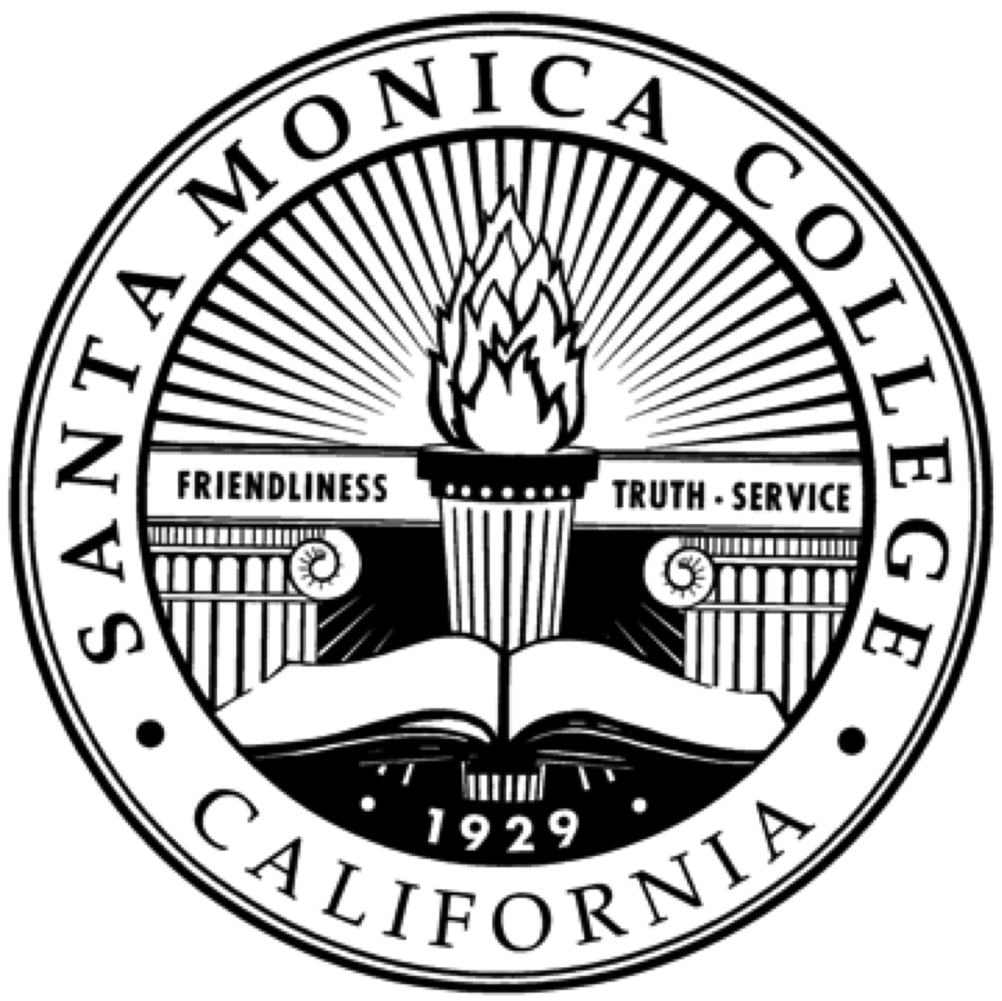 | Santa Monica Community College District  Budget Planning Committee a Subcommittee of the  District Planning and Advisory Council  AGENDA – September 18, 2019

A meeting of the Santa Monica Community College Budget Planning Committee, a subcommittee of the District Planning and Advisory Council (DPAC) will be held on Wednesday, September 18, 2019 at 2:00 pm at the Library 275, 1900 Pico Boulevard, Santa Monica, California.

- Budget Planning Committee Members

- Mitch Heskel, District Representative
- Chris Bonvenuto, District Representative, Co-Chair
- Teresita Rodriguez, District Representative
- Delores Raveling, District Representative
- Jose Hernandez, Academic Senate Representative
- Nate Donahue, Academic Senate Representative
- Matt Hotsinpiller, Faculty Association Representative, Co-Chair
- Peter Morse, Faculty Association Representative
- Martha Romano, CSEA Representative
- Dee Upshaw, CSEA Representative
- Gorman, Dagmar – CSEA Representative
- Mike Roberts, CSEA Representative
- Skander Zmerli, Associated Student Representative
- Daniel Cha, Associated Student Representative
- TBD, Associated Student Representative
- TBD, Associate Student Representative
- Elaine Roque – Interested Party

- Call to Order

- Public Comments
Individuals may address the Budget Planning Subcommittee concerning any subject that lies within the jurisdiction of the Subcommittee by submitting an information card with name and topic on which comment is to be made. The Co-Chairs reserve the right to limit the time for each speaker.
- Agenda

- Approve minutes from August 28, 2019
- Budget Update

- Adjournment

- Future Budget Planning Committee Meetings (Meetings will be on 1st and 3rd Wednesdays of the month, except as noted, and will begin at 2:00, Library Conference Room, Library 275): August 21 (Loft); September 4; September 18; October 2; October 16; November 6; November 20; December TBD

