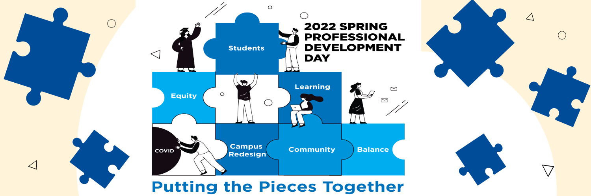
Session Title: Baking with Biddle
Time: 3-4 p.m.
Recipe for Baking with Biddle Session
Category is: Bundt Cake
A Bundt a day will take the stress away

Grab your Bundt pan and let’s bake a traditional pound cake drizzled with lemon orange glaze with Dennis.

Cake Ingredients
8 ounces unsalted butter
8 ounces sour cream
3 cups sugar of choice
6 eggs
2 tablespoons vanilla extract
3 cups cake flour (preferably Swans Down Cake Flour)

Other Necessities
Baking spray
Bundy cake Pan

Lemon-Orange Glaze
1 cup powdered sugar
1 tablespoon Pure Vanilla Extract
grated orange peel
lemon juice

