- Once logged into SMC GPS, you will see your Success Network at the top and Services area at the bottom (as soon below).
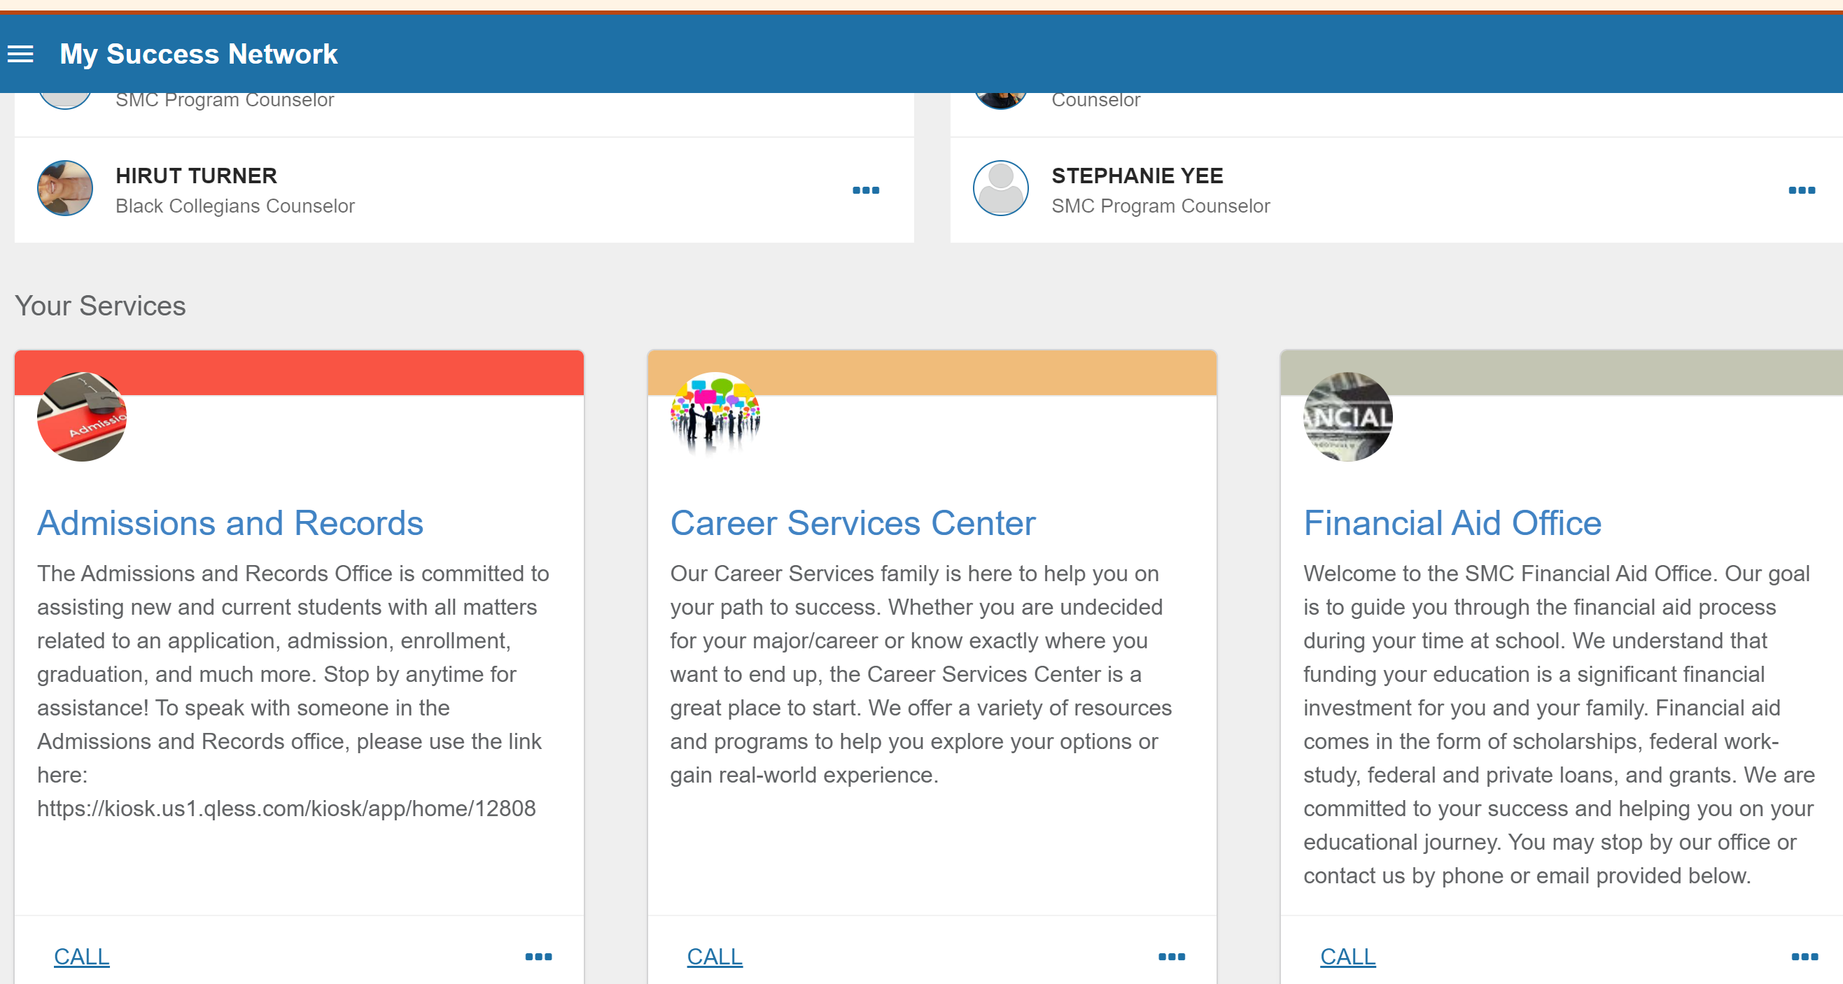

- Scroll down to the service they want and click on that box (i.e. Writing and Humanities Tutoring or Math Tutoring). You will notice the “Schedule” option that shows at the bottom of the box if there are appointments available. Click on the “Schedule” link to directly access the appointment scheduling feature.
- Select the reason for the appointment and click “Continue” at the bottom right
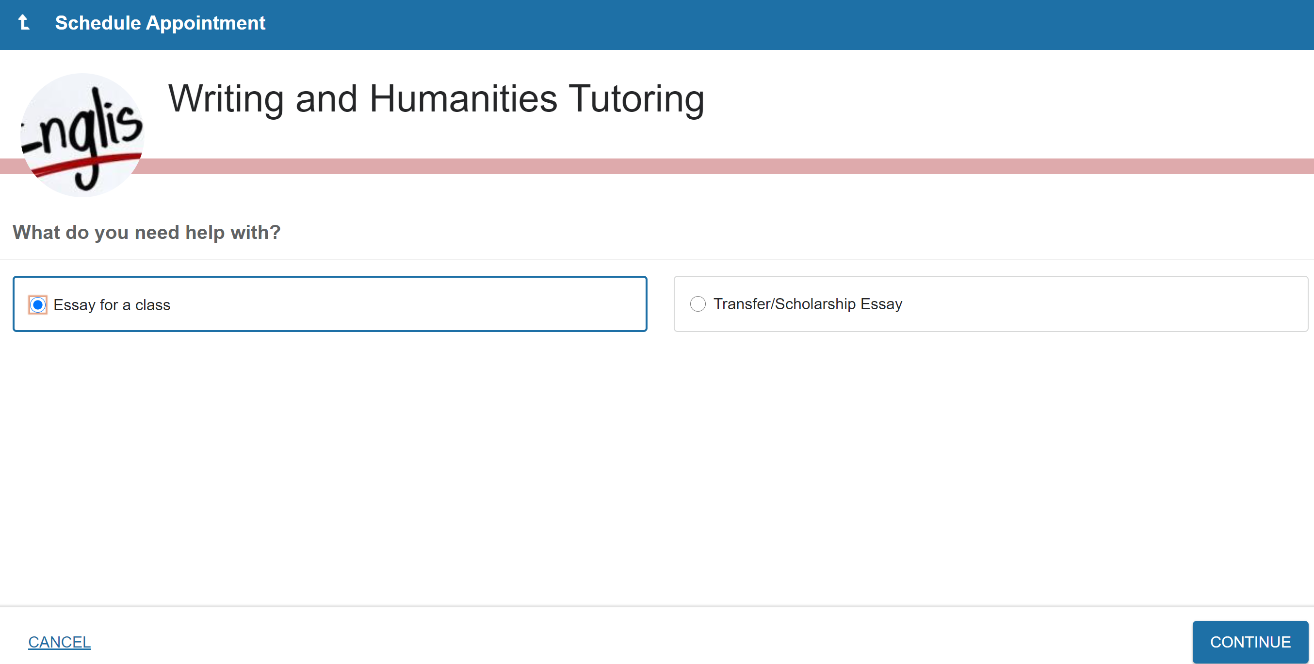
- Select a date and time by scrolling on the right-hand side all the way to the bottom (with “show more times” selected if needed) and then selecting a date, time and/or tutor that they prefer. Once selected, click “Continue” at the bottom right.
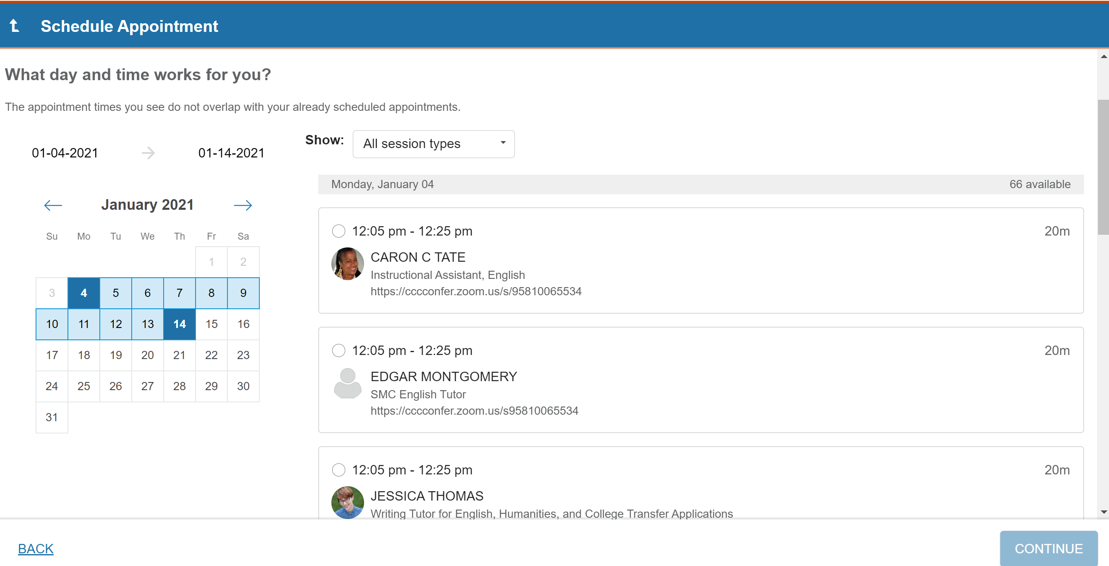
Tutors name and course(s) they tutor
Tutors name and course(s) they tutor
Tutors name and course(s) they tutor
- Finally, enter what you need tutoring for (i.e.- creating a thesis statement, or chapter 2 in Math 54) in box shown in red. Then click the “Confirm” button to officially schedule their appointment.
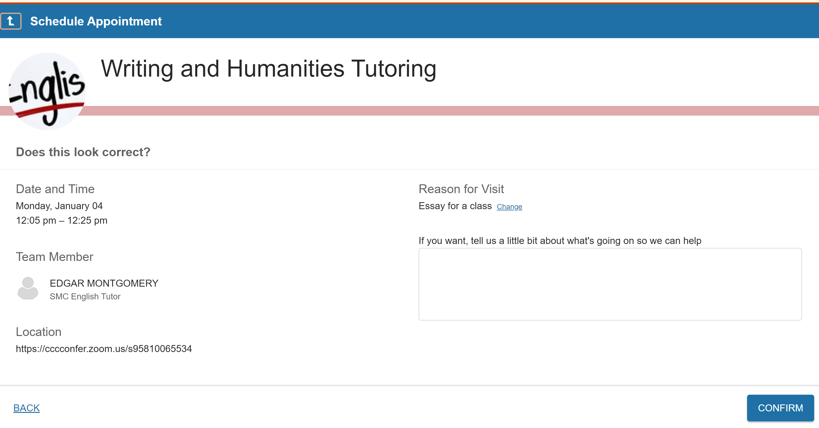
Tutors name and course(s) they tutor
Location of the tutoring session in person or online

